**The London Festival of Gymnastics 2018 presents…… a weekend full of**

**Sun, Sand, Sea and Somersalts**

**On:**

**Friday 5th,**

**Saturday 6th**

**and**

**Sunday 7th October**

**At:**

**The Brentwood Centre**

**Doddinghurst Road**

**Brentwood, Essex**

**CM15 9NN**



14th-16th October 2016

London Festival of Gymnastics

The Brentwood Centre

Doddinghurst Road

Brentwood, Essex

CM15 9NN

**Registration   
General Information**

|  |  |
| --- | --- |
| Name of Club |  |
| BG Club Number |  |
| Contact Name |  |
| Contact Email |  |
| Address |  |
| 🕿 No.Day | Evening |
| Number of people/gymnasts in your party: | People Gymnasts |
| Would you like to be considered to perform in the Friday Gala Evening: (This is done on a selection basis) | Yes  *No* |
| Date and time of arrival | Date: Time: |
| Preference of performance times (this is not guaranteed) | Saturday AM  PM  Sunday AM  PM |
| How many disco tickets do you require at £5 per ticket? **Note the disco will NOT be included in the cost of your festival pass** |  |
| **PAYMENT for disco tickets:** Please make cheques payable to: London Festival of Gymnastics.  Pay on line to: Bank LloydsTSB | Account Name: London Festival of Gymnastics | Sort Code: 309688 | Account Number: 00036545 | |

Please note that you can only have 2 coaches present at the front of the floor whilst your team is performing

**BG Membership and Qualifications**

**British Gymnastics Membership for Gymnasts**

All gymnasts participating at the Festival must be members of British Gymnastics (at a minimum of Bronze Level)

to comply with the insurance cover.

Please note that schools wishing to register to take part in the Festival are covered for insurance if they are members of

British Schools Gymnastics Association and therefore they must quote all membership details with their registration application

**British Gymnastics Membership/Qualifications for Coaches/Chaperones**

The Lead coach with the team at the London Festival must have a minimum of Level 2 in the discipline(s) being performed.

Additional coaches of a minimum level one may also attend.

At least one of the coaches in attendance must have a qualification in the relevant discipline(s) to cover the difficulty of

ALL skills being performed by the gymnasts in the Club’s Festival routine.

Please ensure that all coaches have an up to date Enhanced BG DBS and a current SPC

(Safeguarding and Protecting Children) qualification registered with BG.

Chaperones must have a minimum of Bronze Level British Gymnastics membership and an Enhanced BG DBS.

The British Gymnastics Membership starts on the 1 October so please make sure that registration is made in September 2018

**Full details of BG membership and qualifications for gymnasts and coaches will be required to be entered onto the London Gym Net system**

**once your team has been accepted.**

**Queries about Membership and Qualifications can be directed to:**

**British Gymnastics**

**Image Capture & Welfare Officers & Programme Words**

**Image Capture**

We will be recording performances this year, but if you would like to video your

performance you can bring your own camera, but these will only be allowed in the seating area

(not on the balcony) and NOT in any other areas within the centre.

**Welfare Officers**

There are two Welfare Officers at the festival who are Phillip Jeremy and Sally Tolhurst

**Programme Words**

If you would like to be mentioned in this year’s programme please send a few words and photographs to Tracey Griffiths by

1st September 2018 on the following email address: Ttgriffiths74@gmail.com.

**Equipment**

**CLUB NAME**

Will you be bringing your own Equipment to the London Festival of Gymnastics? (please tick the boxes below)

|  |  |  |
| --- | --- | --- |
| On Friday 5th October | Yes | No |
| On Saturday 6th October | Yes | No |
| On Sunday 7th October | Yes | No |
| Do you require help to unload equipment | Yes | No |

The equipment available for use is listed below. Please tick the appropriate boxes if you would like to use it.

If you do not tick the boxes below then the equipment will not be available for you to use.

|  |  |  |
| --- | --- | --- |
| 4 x Safety Landing Mats | Yes | No. |

Please note that all equipment must be in the loading bay between 8.00am and 9.30am on either day – NO LATER.

**Due to Brentwood fire safety regulations, any equipment arriving after this time will not be allowed into the loading bay.**

If you would like to drop your equipment Friday night, the loading bay will be open from 6.30pm. You will not be able to collect your equipment until the end of the day’s performances.

All equipment must meet Health and Safety requirements as it will be checked per BG manual.

Please complete the form above and send it to the registration department by the ***1st September 2018***

If you have any questions regarding equipment please contact us before the event or speak to us on your arrival.

Please send to:   
**London Festival of Gymnastics Registration Department**

**41 Knole Road, Dartford, Kent DA1 3JN**

**Tel No: 07801 355370**

**Email: tgriffiths74@gmail.com**

**Music**

**CLUB NAME**

|  |  |
| --- | --- |
| Contact Name |  |
| Contact Telephone No. |  |
| Email Address |  |
| Title of Music |  |
| Length of the Music |  |

Please email your music to tgriffiths74@gmail.com and make sure that is a good clear copy. Please make sure that you bring at least 2 copies of music with you, one for warm up and one for backup. Please make sure that the CDs are clearly labelled with Team Name, Routine name and day of performance. If there is more than 1 track then please make sure this is clearly labelled

Due to the popularity of the festival, we are on a tight time schedule and therefore your music must not be longer than 6 minutes inclusive of marching on and off and moving of equipment, if it is any longer than 6 minutes then we may have to cut it on the day.

Please adhere to the copyright law as stated by British Gymnastics. For more information please see the website WWW.PPLUK.COM

Please note that the London Festival Committee and British Gymnastics will not accept any responsibility if legal action is taken against a club if they choose to use Disney, Lloyd Webber or Cirque du Soleil music.

Please send your music with this form by the 1st September:

**London Festival of Gymnastics Registration Department**

**41 Knole Road, Dartford, Kent DA1 3JN**

**Tel No: 07801 355370**

**Email: tgriffiths74@gmail.com**

**Ticket Bookings**

|  |
| --- |
| **Bookings can only be made on line: www.ticketsource.co.uk**  **For more information go to www.londongym.org.uk**  **Tickets will go on sale in July 2018** |

|  |  |  |  |  |  |
| --- | --- | --- | --- | --- | --- |
|  |  | **Booked in Advance** |  | **On the day** |  |
| **Friday 5 October Gala Performance**  The performance is 7.30-9.30pm |  | **£10.00** |  | **£15.00** |  |
| **Saturday 6 or Sunday 7 October**  Morning performances (10.00-1.00pm) |  | **£10.00** |  | **£15.00** |  |
| **Saturday 6 or Sunday 7 October**  Afternoon performances (2.30pm – 5.30pm) |  | **£10.00** |  | **£15.00** |  |
| **Saturday 6 or Sunday 17 October**  All day performance (10am-1pm) and (2.30pm-5.30pm) |  | **£15.00** |  | **£25.00** |  |
| **Group Tickets for morning or afternoon sessions only**  **(Includes 4 people, at least 1 adult over 18)** |  | **£35.00** |  | **£50.00** |  |

Children under 2yrs are permitted free provided they share a seat with an Adult.

There is disabled seating and wheelchair access available.

TICKETS CANNOT BE EXCHANGED OR REFUNDED

We advise you to arrive early as seats are no longer numbered. If your child is performing and you want them to sit with you after their performance they will need a spectator ticket as their gymnast pass will not give them access to the spectator seating.

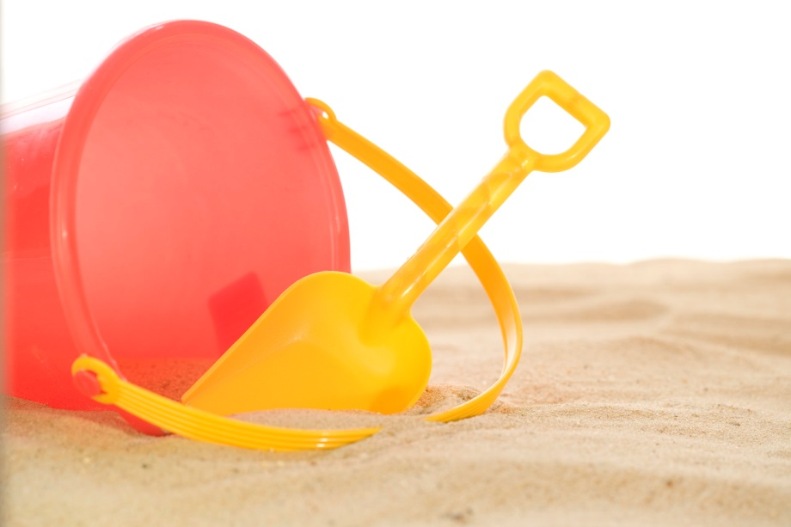**On Saturday 6th October London**

**BEACH PARTY**

**(themed fancy dress)**

**From: 8.00-11.00pm**

**At: Brentwood Leisure Centre**

**Soft drinks available in Marquee**

**Alcoholic Beverages available**

**(ID required)**

**Tickets are £5 each**

**Please order these on the registration form**

**Gala Evening**

**Date:** Friday 5th October

**Time:** 7.30-9.30 (Centre will open at 6.30pm)

**Venue:** Brentwood Centre

Doddinghurst Road

Pilgrims Hatch

Brentwood

Essex, CM15 9NN

We will be selecting a number of teams to perform a 4 minute routine at the Gala Evening.

**Map**



* **Leave the M25 at junction 28 signposted A12 - Chelmsford and A1023 – Brentwood**
* **Take the A1023 towards Brentwood.**
* **After approximately 2 miles turn left at traffic lights onto the A128 Ongar Road**
* **At mini roundabout turn right into Doddinghurst Road.**
* **The Brentwood Centre is on your right after about ¾ of a mile.**

Please be aware that there are road works on the M25 and delays are possible on Friday nights.

**British Gymnastics Policies**

The following British Gymnastics policies must be adhered to:

* Safeguarding and protecting children and vulnerable adults
* Equality
* Anti-doping
* Photography
* Health, Safety & Welfare Policy for Clubs & Affiliated Organisations

All policies can be viewed at the British Gymnastics website [www.british-gymnastics.org](http://www.british-gymnastics.org)

**Key Deadline Reminders**

**1st June – Full registration open**

**July – Spectator tickets go on sale  
  
1st September – Final confirmation of passes and payment (via Gym Net)  
  
1st September – Send us your music**

**1st September – What equipment are you bringing?**

**1st September – Programme words needed**